Case 10-AM,S-Peru-Moche-Figure with headdress and ear spools-Terra cotta-100-700 CE

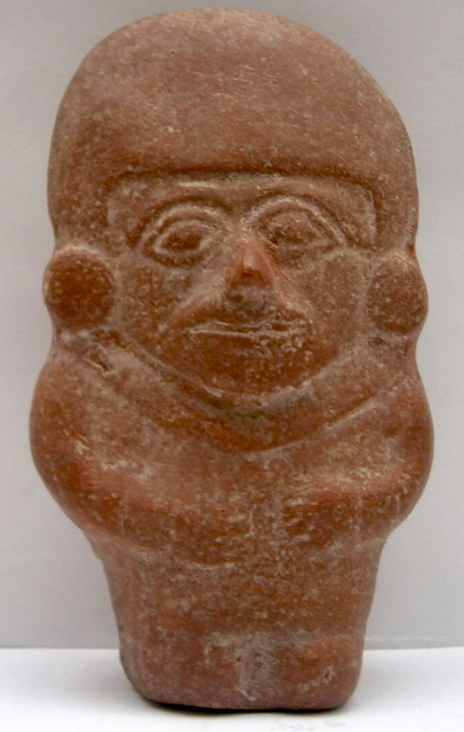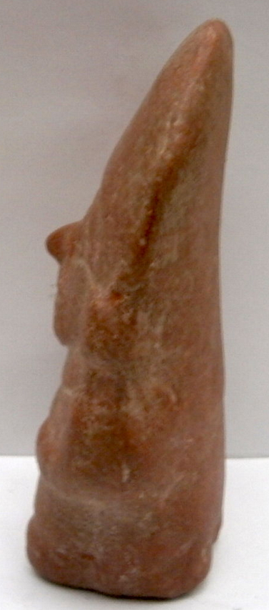
AM,S-Peru-Moche-Figure with headdress and ear spools-Terra cotta-100-700 CE

Case no.: 10
Accession Number:
Formal Label: AM,S-Peru-Moche-Figure with headdress and ear spools-Terra cotta-100-700 CE
Display Description:
This figure may be a Moche shaman, whose mouth appears to be uttering a sound. Sickness among the Moche was believed to be a supernatural attack from the other world of evil spirits, acting on their own or at the bequest of a shaman. The healing shaman divines the identity of the attacker and repels its malevolent power. All shamans have the power to heal and to harm, hence, they are both feared and respected in their communities. Healing is a group endeavor. Father Antonio de la Calancha, an Augustinian monk in Northern Peru wrote in 1638 that curers, Oquetlupuc, were public officials of high privilege and were provided for by the chieftain. Individuals shown "laying on hands'' and individuals holding a characteristic vessel and accompanying dipping stick (a lime gourd used to crush coca leaves and lime to chew) are the paraphernalia of shamans. The lime helped to leach minute grains of cocaine out of the leaves (von Hagen 1964: 104). The shaman calls the women who sing the spirits out of the forest (Haer 1992; 90). Nazca shamans do the singing themselves while attendants perform the music (Hadingham 1987:247 and Gill in 1947; 121). Siona society has a specific song, but the more songs one knows, the more power the shaman has (Matheison Langhon).
LC Classification: F3430.1.
Date or Time Horizon: 400 CE-800 CE
Geographical Area: North coastal Peru
Map, GPS coordinates: -
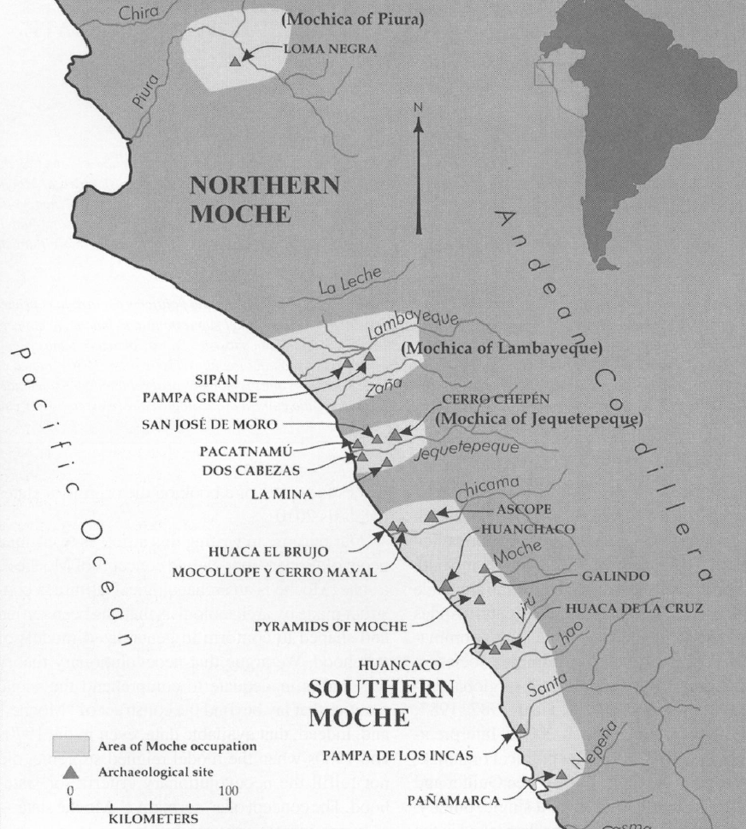
Fig. 8. Map of Moche regions as currently conceived and significant Moche sites. Map courtesy Moro Archaeological program.

Cultural Affiliation: Moche, Mochica
Media: clay; polychrome colors: red, cream, black, skin color
Dimensions: H 4.72 in; 12.0 cm
Weight:
Condition: original
Provenance:
Discussion: (Attributed to Wiki)
Provenance:
Garcia Fernandez collected this ceramic while living in Peru 1950-1980.
Discussion: (attributed to Wiki)
The Desana say that a deity named Viho Mahse was placed in the Milky Way by the Sun as an intermediary between the worlds. Viha means hallucinogenic snuff. He is lord of the spirit world whom the Desana pays visit during trance (Reichel-Dolmatoff 1968; 411). It is also said that the Sun created the jaguar as his representative on Earth (Reichel-Dolmatoff 1968; 28). In Bolivia, Aymara is the name of a great feline deity that is both a protector and a destroyer (Hadingham 1987;247). Modern Quechua are said to suffer from attacks by cocaine minions of the Mountain Weather Deity (Hadingham 1987: 248).
References:
Alva, Walter and Chrisopher R. Donnan. 1993. Royal Tombs of Sipan, Fowler Museum of Cultural History, Los Angeles: UCLA.
Anon. The Salinar Culture Tampere Museum
Bawden, G. 2004. "The Art of Moche Politics". In Silverman, H. Andean Archaeology. Oxford: Blackwell Publishers.
Beck, Roger B.; Black, Linda; Krieger, Larry S.; Naylor, Phillip C.; Shabaka, Dahia Ibo (1999). World History: Patterns of Interaction. Evanston, IL: McDougal Littell. ISBN 0-395-87274-X.
Benson, Elizabeth P. 1972 The Mochica, a culture of Peru. New Yorlr, Washington, D.C.: Praeger Publishers.
Benson, Elizabeth P. 1974. A Man and a Feline in Mochica Art. Washington, D.C.: Dumbarton Oaks, Trustees for Harvard University.
Butters, Castillo and Luis Jaime. "Moche Politics in the Jequetepeque Valley" (PDF). Retrieved 2012-11-23
Butters, Castillo.2007. "The Moche of Northern Perú". In Silverman, H.; Isbell, W. Handbook of South American Archaeology (PDF). Blackwell Press.
Cardenas, Maritza (ed.). "Huacas del Sol y de la Luna – Capital de la Cultura-Mochica" (in Spanish). Retrieved 2012-03-29.
Chapdelaine, Claude; Kennedy, Greg; Uceda Castillo, Santiago (1995). "Neutron activation analysis and local production of ritual ceramics at the Moche site, Peru" (PDF). Bulletin de l'Institut Francais d'Etudes Andines 24 (2): 183–212.
Keys, David. 2000. "The Mud of Hades". Catastrophe: an Investigation into the Origins of the Modern World (1st [American] ed.). New York: Ballantine Books. ISBN 0345444361.
Davidson, Nick. 2 March 2005. "Lost society tore itself apart". BBC Horizon. Retrieved 2005-05-04.
Lovett, Richard A. August 18, 2006. "Photo in the News: Looted Peru Headdress Recovered in London". National Geographic News. Retrieved 2010-12-18.
McClellan III, James E.; Harold Dorn. 2006. Science and Technology in World History: An Introduction. JHU Press; 14 April 2006. p. 40.
Norris, Scott (May 16, 2006). "Mummy of Tattooed Woman Discovered in Peru Pyramid". National Geographic News.
Popson, C. 2012. "Moche Culture". About Peru History. Retrieved 2012-05-22.
Scher, Dr. Sarahh and Steven Zucker. 2015. "Pair of Earflares, Winged Messengers (Moche Culture, Peru)". Smarthistory.
Sharon, Douglas. 2000. Shamanism and the sacred cactus: ethnoarchaeolgical evidence for the San Pedro use in northern Peru. San Diego: San Diego Museum of Man.
Sutherland, Scott. August 29, 2013. "Unearthed Peruvian tomb confirms that women ruled over brutal ancient culture". Yahoo! News. Retrieved 2013-08-29.
Vecchio, Rick. September 15, 2006. "Looted gold headdress returned to Peru". Peru This Week. AP.
Williams. Ann R. 2013. “Tomb of a Powerful Moche Priestess-Queen Found in Peru.” nationalgeographic.com
Weismantel, M. 2004. "Moche sex pots: Reproduction and temporality in ancient South America" (PDF). American Anthropologist. 106 (3): 495–496.
Zucker, Steven, and Dr. Sarahh Scher, 2016. Moche Portrait Head Bottle". Smarthistory.

